Our Team
S. No. | Name of the Staff | Designation
1 | Dr. Ramveer Tanwar | University Librarian | 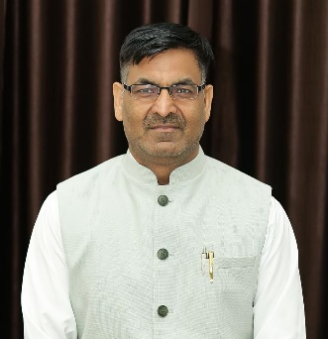
2 | Mr. Arun Singh Thakur | Senior Grade Librarian
3 | Mr. Muktendra Rawat | Librarian
4 | Mr. Himanshu Kumar | Assistant Librarian
5 | Mr. Varun Handa | Assistant Librarian
6 | Mr. Durgesh Ranakoti | Assistant Librarian
7 | Dr. Rakhi Sharma | Assistant Librarian
8 | Ms Madhu Bala | Assistant Librarian
9 | Dr. Kundan Dimri | Assistant Librarian
10 | Ms. Jainab | Assistant Librarian
11 | Mr. Kamal Rautela | Assistant Librarian
12 | Mr. Jai Prakash | Library Assistant
13 | Mr. Santan Singh | Library Record Keeper
14 | Vichitra Dangwal | Library Assistant
15 | Mr. Kamal | Library Assistant
16 | Mr. Naveen Chandra Pandey | Library Assistant
17 | Mr. Rajendra Tiwari | Library Assistant
18 | Ms Sirjan Sarna | Library Assistant
19 | Ms Simran | Library Assistant

